Practical No.07

Q.1 Accept name in text field in the form and display it.

<!DOCTYPE html>
<html ng-app="myApp">
<head>
<title>Name Display</title>
<script src="https://ajax.googleapis.com/ajax/libs/angularjs/1.8.2/angular.min.js"></script>
</head>

<body ng-controller="myCtrl">

<form>
Enter Name:
<input type="text" ng-model="name">
</form>

<h3>Hello {{ name }}</h3>

<script>
var app = angular.module("myApp", []);
app.controller("myCtrl", function($scope) {
$scope.name = "";
});
</script>

</body>
</html>
Output:-

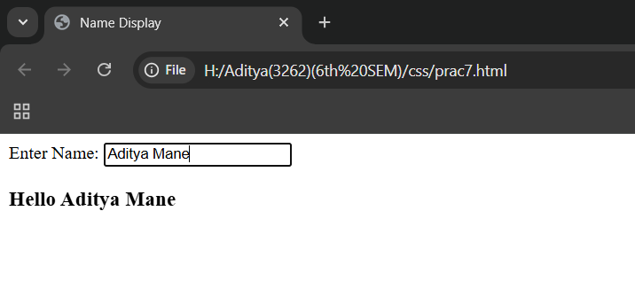
Q.2] Created a registration form. The user fills in the details and clicks on the submit button. On clicking on the submit button the details filled by the user are displayed
<!DOCTYPE html>
<html ng-app="app">
<head>
<script src="https://ajax.googleapis.com/ajax/libs/angularjs/1.8.2/angular.min.js"></script>
</head>

<body ng-controller="ctrl">

<form>
Name:
<input type="text" ng-model="name"><br><br>

Email:
<input type="email" ng-model="email"><br><br>

<button ng-click="submit()">Submit</button>
</form>

<p ng-show="show">
Name: {{ dname }} <br>
Email: {{ demail }}
</p>
<script>
angular.module("app", []).controller("ctrl", function($scope) {
$scope.show = false;

$scope.submit = function() {
$scope.dname = $scope.name;
$scope.demail = $scope.email;
$scope.show = true;
};
});
</script>
</body>
</html>

Output :-
